**EXPERIMENT 1**

**NAME: Vishal Shashikant Salvi UID: 2019230069**

**CLASS: TE COMPS BATCH: C**

**Aim:** To Perform sampling and reconstruction of a signal

**Theory:**

**Analog signal:**

An analog signal is time-varying and generally bound to a range (e.g. +12V to -12V), but there is an infinite number of values within that continuous range. An analog signal uses a given property of the medium to convey the signal’s information, such as electricity moving through a wire. In an electrical signal, the voltage, current, or frequency of the signal may be varied to represent the information. Analog signals are often calculated responses to changes in light, sound, temperature, position, pressure, or other physical phenomena.

When plotted on a voltage vs. time graph, an analog signal should produce a smooth and continuous curve. There should not be any discrete value changes.

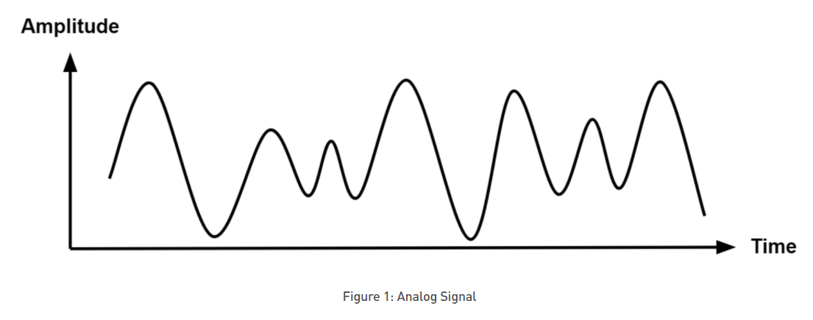

**Advantages to using analog signals, including analog signal processing (ASP) and communication systems, include the following:**

* Analog signals are easier to process.
* Analog signals best suited for audio and video transmission.
* Analog signals are much higher density, and can present more refined information.
* Analog signals use less bandwidth than digital signals.
* Analog signals provide a more accurate representation of changes in physical phenomena, such as sound, light, temperature, position, or pressure.
* Analog communication systems are less sensitive in terms of electrical tolerance.

**Disadvantages to using analog signals, including analog signal processing (ASP) and communication systems, include the following:**

* Data transmission at long distances may result in undesirable signal disturbances.
* Analog signals are prone to generation loss.
* Analog signals are subject to noise and distortion, as opposed to digital signals which have much higher immunity.
* Analog signals are generally lower quality signals than digital signals.

**Digital signal:**

A digital signal is a signal that represents data as a sequence of discrete values. A digital signal can only take on one value from a finite set of possible values at a given time. With digital signals, the physical quantity representing the information can be many things:

* Variable electric current or voltage
* Phase or polarization of an electromagnetic field
* Acoustic pressure
* The magnetization of a magnetic storage media

Digital signals are used in all digital electronics, including computing equipment and data transmission devices. When plotted on a voltage vs. time graph, digital signals are one of two values, and are usually between 0V and VCC (usually 1.8V, 3.3V, or 5V)

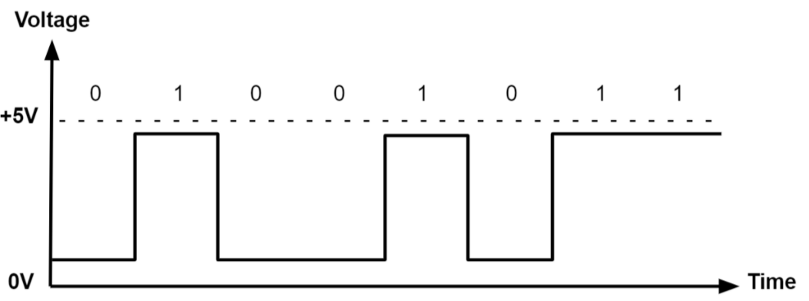

**Advantages to using digital signals, including digital signal processing (DSP) and communication systems, include the following:**

* Digital signals can convey information with less noise, distortion, and interference.
* Digital circuits can be reproduced easily in mass quantities at comparatively low costs.
* Digital signal processing is more flexible because DSP operations can be altered using digitally programmable systems.
* Digital signal processing is more secure because digital information can be easily encrypted and compressed.
* Digital systems are more accurate, and the probability of error occurrence can be reduced by employing error detection and correction codes.
* Digital signals can be easily stored on any magnetic media or optical media using semiconductor chips.
* Digital signals can be transmitted over long distances.

**Disadvantages to using digital signals, including digital signal processing (DSP) and communication systems, include the following:**

* A higher bandwidth is required for digital communication when compared to analog transmission of the same information.
* DSP processes the signal at high speeds, and comprises more top internal hardware resources. This results in higher power dissipation compared to analog signal processing, which includes passive components that consume less energy.
* Digital systems and processing are typically more complex.

**Continuous signals:**

Continuous-time signals or analog signals are defined for every value of time and they take on values in the continuous interval (a...b), where a can be - $inf$ and b can be $inf$. Mathematically, these signals can be described by functions of a con­tinuous variable.

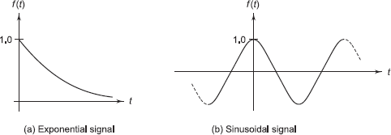

* A continuous signal or a continuous-time signal is a varying quantity (a signal) whose domain, which is often time, is a continuum (e.g., a connected interval of the reals). That is, the function's domain is an uncountable set. The function itself need not be continuous. To contrast, a discrete time signal has a countable domain, like the natural numbers.
* A signal of continuous amplitude and time is known as a continuous-time signal or an analog signal. This (a signal) will have some value at every instant of time. The electrical signals derived in proportion with the physical quantities such as temperature, pressure, sound etc. are generally continuous signals. Other examples of continuous signals are sine waves, cosine wave, triangular wave, etc.
* The signal is defined over a domain, which may or may not be finite, and there is a functional mapping from the domain to the value of the signal. The continuity of the time variable, in connection with the law of density of real numbers, means that the signal value can be found at any arbitrary point in time.
* A typical example of an infinite duration signal is:



* A finite duration counterpart of the above signal could be:



**Discrete signals:**

A discrete-time signal *x(n)* is a function of an inde­pendent variable that is an integer. It is graphically represented as below:

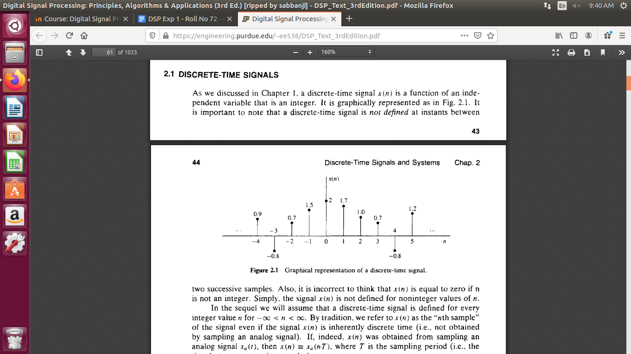

* It is important to note that a discrete-time signal is not defined at instants between two successive samples.
* By tradition, we refer to x(n) as the “nth sample” of the signal even if the signal x(n) is inherently discrete time. If, indeed, x(n) was obtained from sampling an analog signal xa(t), then x(n) = xa(nT), where T is the sampling period.
* Besides the graphical representation of a discrete-time signal or sequence as illustrated above, there are some alternative representations:

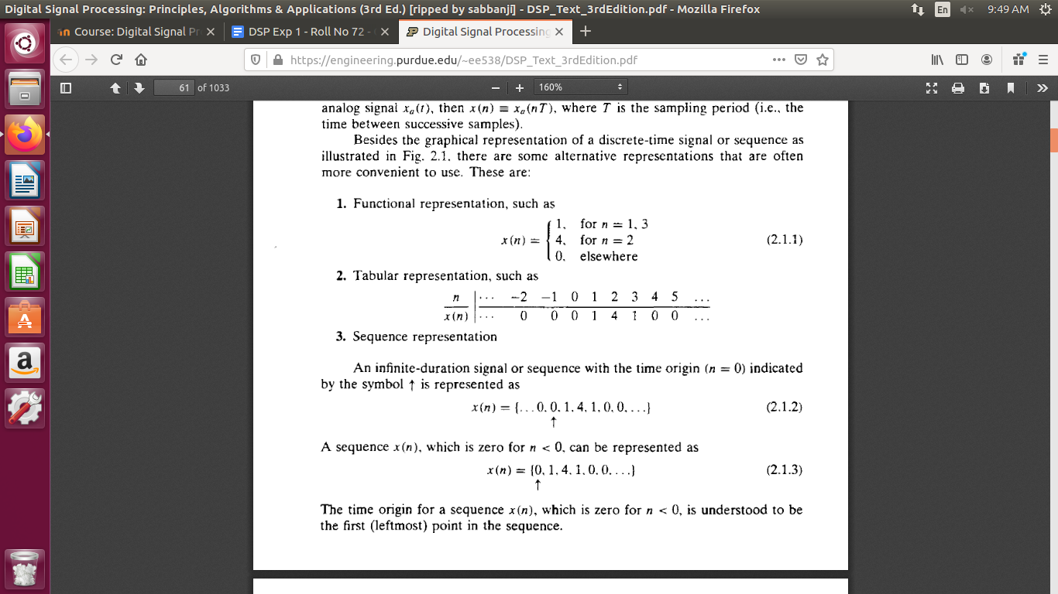

**Sampling theory:**

Sampling is the process of recording the values of a signal at given points in time. For A/D converters, these points in time are equidistant. The number of samples taken during one second is called the sample rate. The mathematical description of the ideal sampling is the multiplication of the signal with a sequence of direct pulses.

In real A/D converters the sampling is carried out by a sample-and-hold buffer. The sample-and-hold buffer splits the sample period in a sample time and hold time. In case of a voltage being sampled, a capacitor is switched to the input line during the sample time. During the hold time it is detached from the line and keeps its voltage.

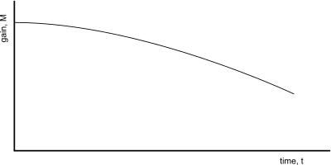

Continuous time signal

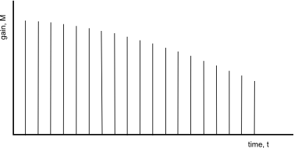

Discrete time signal

**nyquist rate:**

Suppose that a signal is band-limited with no frequency components higher than **W** Hertz. That means, **W** is the highest frequency. For such a signal, for effective reproduction of the original signal, the sampling rate should be twice the highest frequency.

Which means,

fS=2WfS=2W

Where,

* fSfS is the sampling rate
* **W** is the highest frequency

This rate of sampling is called as **Nyquist rate**.

A theorem called, Sampling Theorem, was stated on the theory of this Nyquist rate.

**Reconstruction**

Reconstruction is the process of creating an analog voltage (or current) from samples. A digital-to-analog converter takes a series of binary numbers and recreates the voltage (or current) levels that corresponds to that binary number. Then this signal is filtered by a lowpass filter.

This process is analogous to interpolating between points on a graph, but it can be shown that under certain conditions the original analog signal can be reconstructed exactly from its samples. Unfortunately, the conditions for exact reconstruction cannot be achieved in practice, and so in practice the reconstruction is an approximation to the original analog signal.

Reconstruction is the process of transforming x(n) back to x(t)

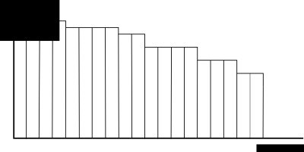

Reconstructed signal view

**Code:**

**Question 1:**

#. Consider the analog signal X(t)= 3cos200?t+ 2cos300?t

#Sketch the signal x(t) for 0 < t < 0.6 s

t = 0:0.0001:0.6;

x = 3*cos(200*pi*t) + 2*cos(300*pi*t);

subplot(5,1,1)

plot(t, x);

title("Continous time signal");

xlabel("time");

ylabel("amplitude");

grid on;

#1. If Fs=100Hz, What is the discrete-time signal after sampling?

n = 0:1:100;

Fs = 100;

t = n/Fs;

x1 = 3*cos(200*pi*t) + 2*cos(300*pi*t);

subplot(5,1,2);

stem(t, x1);

title("Discrete-time signal for FS = 100");

xlabel("n");

ylabel("amplitude");

grid on;

#2. If Fs=80Hz, What is the discrete-time signal after sampling?

n = 0:1:100;

Fs = 80;

t = n/Fs;

x2 = 3*cos(200*pi*t) + 2*cos(300*pi*t);

subplot(5,1,3);

stem(t, x2);

title("Discrete-time signal for FS = 80");

xlabel("n");

ylabel("amplitude");

grid on;

##3. Can the original signal reconstructed with the given samplingfrequency?

FS = 100

F1 = 100

F2 = 150

FMAX = max(F1,F2)

if(FS>=2*FMAX)

fprintf("Reconstruction is Possible")

FS = 100

t = 0:0.0001:0.6;

X11 = 3*cos((200/100)*pi*t*Fs) + 2*cos((300/100)*pi*t*Fs);

subplot(5,1,4)

plot(t,X11);

title("Reconstructed Signal FS = 100 ")

grid on; xlabel('time'); ylabel('amplitude')

else

fprintf("Reconstruction is not Possible")

FS = 100

t = 0:0.0001:0.6;

X11 = 3*cos((200/100)*pi*t*Fs) + 2*cos((300/100)*pi*t*Fs);

subplot(5,1,4)

plot(t,X11);

title("Reconstructed Signal FS = 100 ")

grid on; xlabel('time'); ylabel('amplitude')

endif

FS = 80

F1 = 100

F2 = 150

FMAX = max(F1,F2)

if(FS>=2*FMAX)

fprintf("Reconstruction is Possible")

t = 0:0.0001:0.6;

FS = 80

X12 = 3*cos((200/80)*pi*t*Fs) + 2*cos((300/80)*pi*t*Fs);

subplot(5,1,5)

plot(t,X12);

title("Reconstructed Signal FS = 80")

grid on; xlabel('time'); ylabel('amplitude')

else

fprintf("Reconstruction is not Possible")

t = 0:0.0001:0.6;

FS = 80

X12 = 3*cos((200/80)*pi*t*Fs) + 2*cos((300/80)*pi*t*Fs);

subplot(5,1,5)

plot(t,X12);

title("Reconstructed Signal FS = 80")

grid on; xlabel('time'); ylabel('amplitude')

endif

**Output:**

**Question 1:**

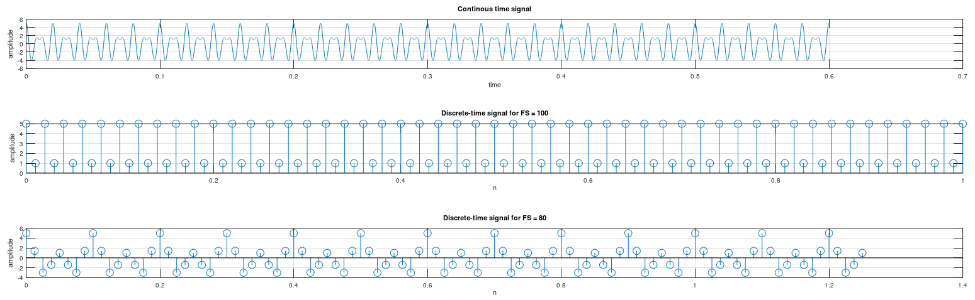

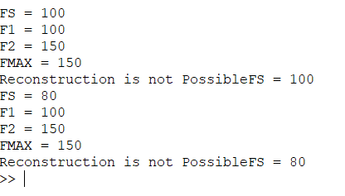

**Code:**

**Question 2:**

#Consider the analog signal X(t) = 3cos250 πt + 10sin30 πt - cos100 πt

#Sketch the signal x(t) for 0 < t <0.5s.

t = 0:0.01:0.5

X = 3*cos(250*pi*t) + 10*sin(30*pi*t) - cos(100*pi*t)

subplot(5,1,1)

plot(t,X);

title("Continous time signal")

grid on; xlabel('time'); ylabel('amplitude')

#1. If Fs=280Hz, What is the discrete-time signal after sampling?

n = 0:1:100

FS = 280

t = n/FS

X1 = 3*cos(250*pi*t) + 10*sin(30*pi*t) - cos(100*pi*t)

subplot(5,1,2)

stem(t,X1)

title("Discrete-time signal for FS = 280")

grid on; xlabel('n'); ylabel('amplitude')

#2. If Fs=350Hz, What is the discrete-time signal after sampling?

n = 0:1:100

FS = 350

t = n/FS

X2 = 3*cos(250*pi*t) + 10*sin(30*pi*t) - cos(100*pi*t)

subplot(5,1,3)

stem(t,X2)

title("Discrete-time signal for FS = 350")

grid on; xlabel('n'); ylabel('amplitude')

#3. Can the original signal reconstructed with the given sampling frequency?

FS = 280

F1 = 125

F2 = 15

F3 = 50

FMAX = max(F1,F2)

FMAX = max(FMAX,F3)

if(FS>=2*FMAX)

fprintf("Reconstruction is Possible")

FS = 280

t = 0:0.01:0.5

X11 = 3*cos((250/280)*pi*t*Fs) + 10*sin((30/280)*pi*t*Fs) - cos((100/280)*pi*t*Fs);

subplot(5,1,4)

plot(t,X11);

title("Reconstructed Signal FS = 280 ")

grid on; xlabel('time'); ylabel('amplitude')

else

fprintf("Reconstruction is not Possible")

FS = 280

t = 0:0.01:0.5

X11 = 3*cos((250/280)*pi*t*Fs) + 10*sin((30/280)*pi*t*Fs) - cos((100/280)*pi*t*Fs);

subplot(5,1,4)

plot(t,X11);

title("Reconstructed Signal FS = 280 ")

grid on; xlabel('time'); ylabel('amplitude')

endif

FS = 350

F1 = 125

F2 = 15

F3 = 50

FMAX = max(F1,F2)

FMAX = max(FMAX,F3)

if(FS>=2*FMAX)

fprintf("Reconstruction is Possible")

t = 0:0.01:0.5

FS = 350

X12 = 3*cos((250/350)*pi*t*Fs) + 10*sin((30/350)*pi*t*Fs) - cos((100/350)*pi*t*Fs);

subplot(5,1,5)

plot(t,X12);

title("Reconstructed Signal FS = 350")

grid on; xlabel('time'); ylabel('amplitude')

else

fprintf("Reconstruction is not Possible")

t = 0:0.01:0.5

FS = 350

X12 = 3*cos((250/350)*pi*t*Fs) + 10*sin((30/350)*pi*t*Fs) - cos((100/350)*pi*t*Fs);

subplot(5,1,5)

plot(t,X12);

title("Reconstructed Signal FS = 350")

grid on; xlabel('time'); ylabel('amplitude')

endif

**Output:**

**Question 2:**

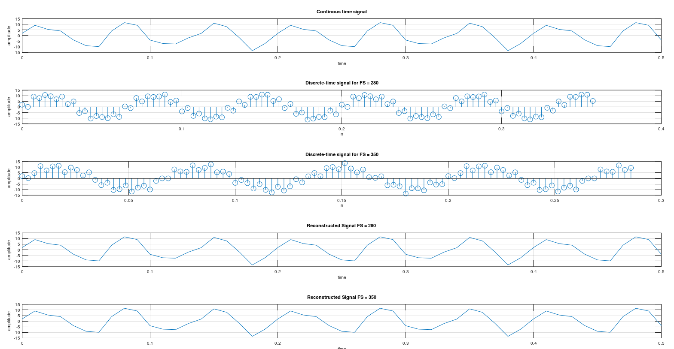

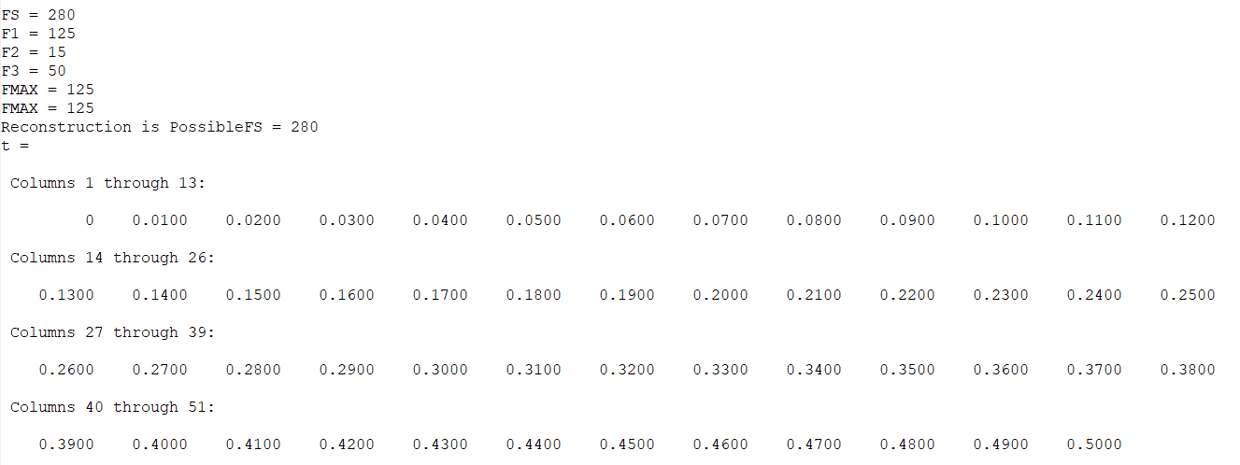

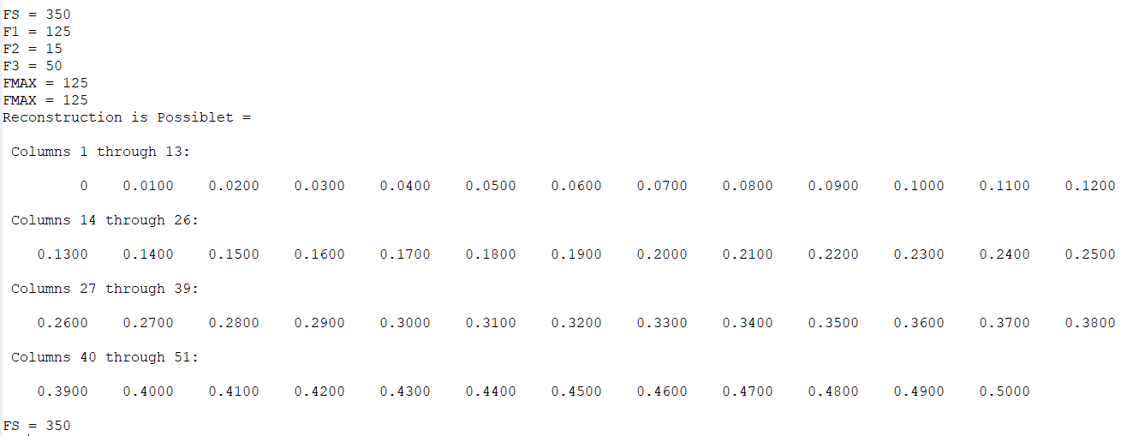

**Conclusion:**

Thus through this experiment I have understood concepts of continuous and discrete time signals, sampling and reconstruction along with Nyquist sampling theorem in octave tool.